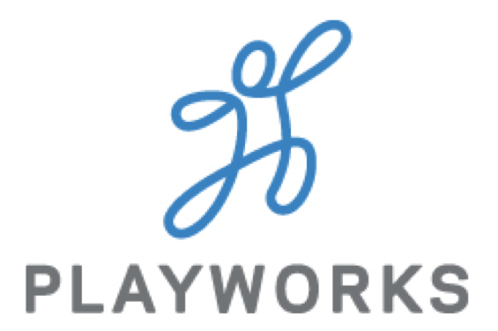
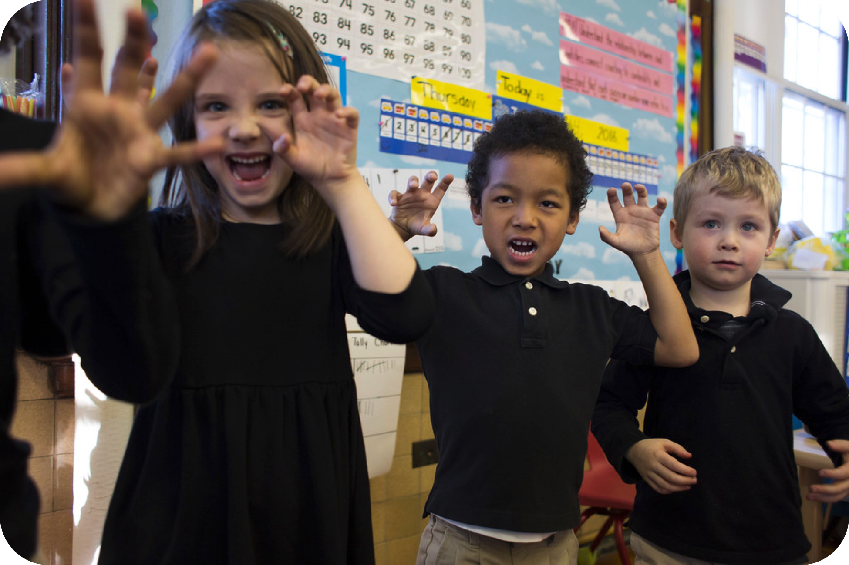
Playworks Pro Media Kit
Thank you for partnering with Playworks! We hope these resources will help you involve parents and your community in your school’s commitment to safe and healthy play.

- About Playworks  - Playworks Announcement  - Videos  - Brand Resources | - Social Media Posts  - Website Language  - Monthly Newsletter Stories  - Press Release Sample
1) About Playworks
Playworks is the leading national nonprofit leveraging the power of play to transform children’s social and emotional health. Playworks is changing school culture by leveraging the power of safe, fun, and healthy play at school every day. Playworks’ vision is for 3.5 million kids in 7,000 elementary schools nationwide to experience safe and healthy play every day by 2020.

2) Playworks Announcement
[Insert school/organization name] is committing to making recess a fun, inclusive place for every kid in our community to play every day. That’s why we’re bringing Playworks Pro to strengthen our community.

A Playworks Trainer will work with our staff to shape recess in a way that fosters social and emotional learning and builds leadership skills in our kids. We will learn techniques to transform our environment—from the playground to the classroom. This exciting opportunity has been made possible by [insert funders if you need to recognize anyone].

3) Videos
- Watch and share: Playworks Pro
- Watch and share: Other videos about Playworks

4) Other Brand Resources
- Logos, press kit, resources for media
- Playworks store (Playworks shirts, extra equipment, etc.)

5) Sample Social Media Posts
Facebook
[Insert school/organization name] is being trained by Playworks so we can ensure every recess is a safe and healthy environment for every kid. We’re excited to be hosting this course: [Select/link to the service you’re getting from the menu of our Pro services here: http://www.playworks.org/pro/pro-programs].

LinkedIn
We’re teaming up with Playworks for hands-on training to help our staff bring out the best in every kid through play! By going through the [insert name of training] training, our team will find new ways to give every kid opportunities for safe and healthy play—every day. www.playworks.org/pro

Twitter
Our team is committed to making sure every kid has a great experience on the playground. We’re partnering with @Playworks: www.playworks.org/pro #Recess #ProfessionalDevelopment

After Your Training(s)
Post a blog to LinkedIn about the experience and a photo album to Facebook highlighting the games you learned. Tag @Playworks, so we can share with Playworks schools and organizations around the country!

6) Sample Website Language
Pick from the paragraphs below to include just the information that is most relevant for your school community. Feel free to adapt!

Playworks Recess
[School Name] is proud to partner with Playworks to make recess a fun, inclusive time for every student in our community. Playworks is the leading nonprofit in [State or Region] and nationally using play to transform schools. A Playworks recess creates a place for every kid on the playground to feel included, be active, and build valuable social and emotional skills.

Outcomes
On Playworks playgrounds across the country, kids play hard, cheer loud, and high five with joy. They settle their conflicts quickly and fairly with Rock Paper Scissors, and they carry a feeling of empowerment and belonging with them into their classrooms, back to their neighborhoods, and out into the world.

OR
What happens at recess matters throughout the day. By making sure that all kids have opportunities for safe and healthy play at recess, Playworks helps schools reduce bullying behaviors, provide more time for classroom teaching, and increase physical activity.

OR
Playworks helps kids grow as leaders, giving them the social and emotional skills they need to thrive inside and outside of the classroom. At a Playworks school, every student is included regardless of athletic ability, academic skills, or background.

[School Name] and Playworks Pro

We are partnering with Playworks through their Playworks Pro service. A Playworks trainer will work with our teachers and administrators to shape recess in a way that fosters social and emotional learning and builds leadership skills in our kids. We’ll learn techniques to positively transform our school environment, from the playground to the classroom. You can learn more by visiting www.playworks.org/how.

We are in the process of implementing Playworks for our students and expect to see a big impact on our playground and in our classrooms. You can expect to hear more as the year progresses.

OR
Playworks’ vision is that every child will have access to safe, fun, and healthy play every day. [School Name] is proud to be part of this movement [as the first school in (School District/City/State—if true for your school) to make play a priority]!
Examples from Other Playworks Schools
The Waldorf School, Baltimore, MD (blog post)
Galway Education Center, Ireland (video)
Rooftop School, San Francisco, CA (webpage)
PS 9 Brooklyn, New York City, NY (webpage)
Desert Star School, Avondale, AZ (announcement)

7) Sample Monthly Newsletter Content
Does your school send home a monthly newsletter for parents? Do you share tips on your website? Playworks has lots of resources to get families playing together. Here is an example calendar:

- July: Looking for games to play at home? Search for games in the Playworks Game Library.
- August: Back to school means back to homework. Here are a few ideas for helping your child balance homework with play.
- September: Kids who feel accepted and included at school learn better. See why [School Name] is partnering with Playworks. [link to Playworks announcement on your website]
- October: What is the difference between bullying and teasing? How can you help your child tell the difference? Here are a few ideas.
- November: Playworks is already making a difference at recess! Here is one of the games students love to play. [share photos from your school and pull a description from the Playworks Game Library]
- December: Laughter makes the holidays bright! Here are 20 funny conversation prompts to get your family laughing together over winter break.
- January: All cooped up inside this winter? Try these 6 games to get kids moving inside!
- February: Studies show that people who are kind are happier and healthier. Here are 12 fun activities to help your kids practice kindness.
- March: This year, our school has been prioritizing [insert focus area, like character education, physical activity, etc.]. A safe, healthy recess is part of that! [share a photo of kids playing at recess.]
- April: Looking for quick, easy games to play at home? Here are 6 fun games that you can play with just paper and pencil!
- May: For teacher appreciation week, please also join us in celebrating our staff on the playground! [share a photo or quick interview with your Recess Coach]
- June: Looking for a great way to play outside with your kids this weekend? Try these games to play with your kids at the park!
8) Sample Partnership Press release
Below is a sample press release to announce your partnership to local media. Reach out to your regional Playworks office for help filling in the blanks.

[SCHOOL] STANDS UP FOR SAFE AND HEALTHY PLAY WITH PLAYWORKS

National Nonprofit to Enhance Recess and Encourage Social and Emotional Learning
[CITY, STATE, DATE] — [SCHOOL] commits to providing safe and healthy play for students by joining forces with Playworks (www.playworks.org), a leading nonprofit that believes in the power of play to bring out the best in every kid. Beginning [DATE], Playworks will provide Playworks Pro training services to school staff, paraprofessionals, and after-school care providers to strengthen our school community through play.

[QUOTE FROM PRINCIPAL ABOUT HOW EXCITED YOU ARE TO ADD THIS SERVICE]

Playworks currently works with [XX] schools and [XX] children annually in [REGION]. Their hands-on professional development workshops and collaborative consultation provide step-by-step guidance that will provide [SCHOOL] with the tools needed to create an inclusive school environment.

[QUOTE FROM PLAYWORKS EXECUTIVE DIRECTOR OR COACH ABOUT WHY PLAYWORKS IS IMPORTANT]

The Playworks program leverages the power of play to encourage social and emotional learning and lifelong skills like empathy, leadership, and conflict resolution. According to a 2015 study published in the American Journal of Public Health, students who develop strong social and emotional skills are twice as likely to graduate from college and 46% more likely to have a full-time job by age 25 than their peers.

Additionally, Playworks schools see improved school climate with fewer bullying behaviors, increased feelings of safety among students, and more vigorous physical activity. Teachers also report recovering learning time by spending less time transitioning from recess to learning. For more information about Playworks, visit http://www.playworks.org.

About Playworks [REGION]
Playworks is the leading nonprofit leveraging the power of play before, during, and after school to transform children’s physical and emotional health. Playworks currently serves more than XX schools and reaches more than XX students directly and through professional training services in [REGION]. For more information, visit www.playworks.org.

