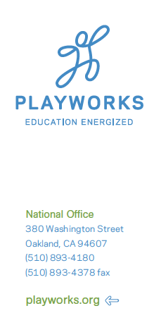

[INSERT MONTH, DAY, YEAR]

Dear [INSERT NAME}:

Playworks is the only non profit organization in the country implementing a play and physical activity program at recess that improves children’s health and well-being both on the playground and in the classroom. Playworks is exceptional in that we deliver a developmentally-appropriate prevention and early intervention program to K-6th grade children through professional development to adults who work with youth at recess or play activities through schools or out of school time programs.

Playworks Training has a variety of intellectual properties which are copyrighted. Dissemination of Playworks principles began in 1997. Copyright protection includes all Playworks Training posters, curriculum binders, packets, training sessions and handouts.

Playworks is a sole source of Playworks Training curriculum, materials and services. Playworks Training is not available anywhere other than from Playworks. Only Playworks staffs are sanctioned to deliver Playworks professional development workshops which use the Playworks copyrighted materials.

Any questions related to sole source issues should be directed to Elizabeth Cushing, President and Chief Operating Officer.

Sincerely,

Elizabeth Cushing
President and Chief Operating Officer
Playworks

