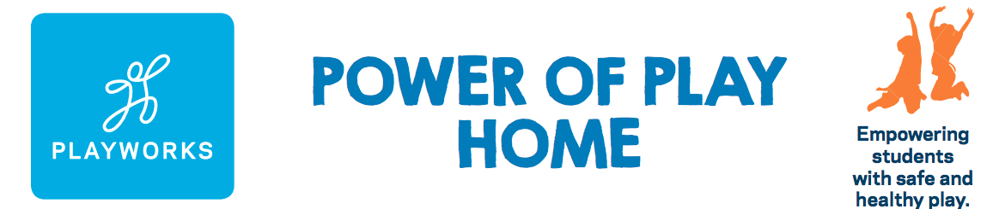

Power of Play Home Pledge Form

Name:
Office Name:
Office Address:
Home Address:
Preferred E-mail:
Telephone:

New Partner
I believe in the power of play and agree to contribute the amount of:

___$25 ___$50 ___$75 ___$100 Other $_____________
*per transaction
Current Partner
I believe in the power of play even more now, and will increase my contribution to:

___$25 ___$50 ___$75 ___$100 Other $_____________
*per transaction
I will make my gift via:
- Commission Instructions
- Check – please make check out to Playworks Education Energized
- Credit Card – can be made online at playworks.org/arizona

Partner Signature Date
Once you have completed the Power of Play Home Pledge Form, please save and e-mail a copy to the Playworks team at Suzanne.percy@playworks.org. Thank you for believing in the Power of Play. Game on!

