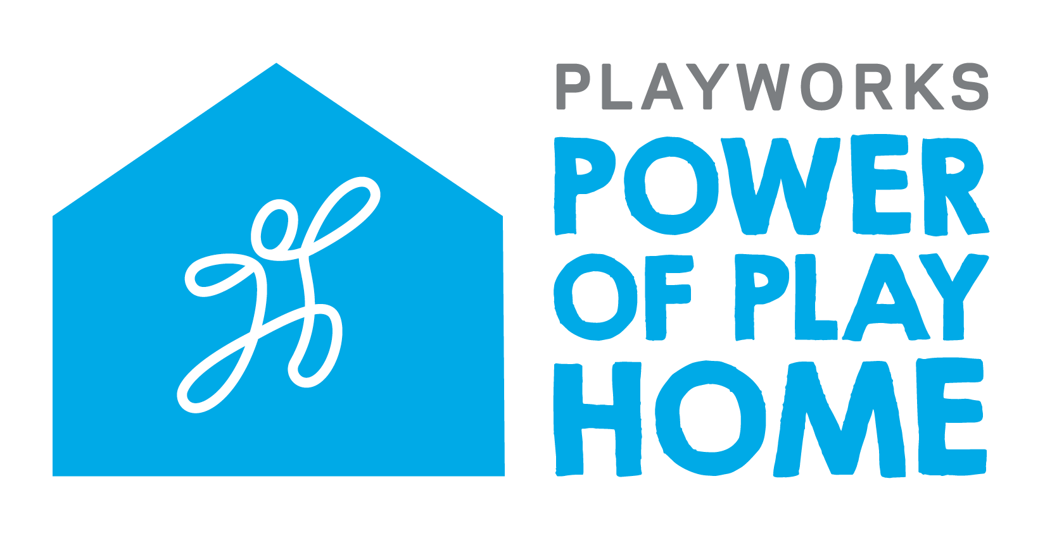 FAQ’s
What is the Power of Play Home Project?
Professionals from the real estate industry have come together to make real, lasting change in the communities they serve. Each team member has committed to direct a portion of every transaction to financially support Playworks Arizona to bring safe and healthy play to all kids.

Be a part of the solution and join the Power of Play Home Project today! Together we can end schoolyard bullying, improve learning environments and create the citizens and workforce leaders we will need in the future!

How do I sign up?
You can join our movement by completing a Commitment From and sharing that with Playworks by emailing Suzanne Percy at Suzanne.percy@playworks.org.

What happens after I sign up?
Upon receipt of your Commitment Form, the Playworks staff will send you a Welcome Packet that will include the following information:
- A copy of your Commitment Form for your records
- Customizable brochure templates you can use to share your involvement in the program
- Directions on how to order sign riders
- Pre-fillable letters of explanation to give your client
- Pre-fillable certificate to give your client
- Power of Play Donation form (in case your client wants to match your gift:)
- A short video from a Jr. Coach that you can share with your clients as a Thank you

Will I get a tax receipt for my donation?
You bet! Each time Playworks Arizona receives your contribution, we will gratefully send an acknowledgement that can be used for tax purposes.

What if my client wants to match my donation?
That would be awesome! They can do this by completing the General Donation Form that will be in your Welcome Packet.

Who is my contact at Playwork?
For any questions about this program, please contact Suzanne Percy, Development Director, Playworks Arizona at 602.818.4790 or by email at Suzanne.Percy@Playworks.org

Thank you for believing in the Power of Play. Game on!

