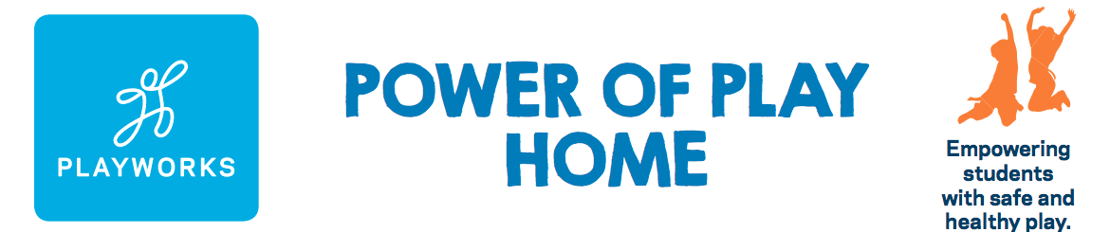

Power of Play Home Donation Form

I just learned about the Power of Play Home Program and you can count me in too!
Name:
Home Address:
Preferred Email:
Telephone:

Donation Details

I would like to make a gift of $

I will make my gift via:
- Check – please make check out to Playworks Education Energized
- Credit Card –online at playworks.org/Arizona, or by completing below:
CC #: Exp Date: CV code:

Donor Signature Date

How Did You Hear About Us? Care to learn more?

Please share with us how you learned about the Power of Play Home Program?

We would love to share more about Playworks with you. Would you be interested in visiting one of our schools and seeing the Power of Play in action?

- Yes, please do.
- Not today, but thank you.

Thank you for believing in the Power of Play. Game on!

