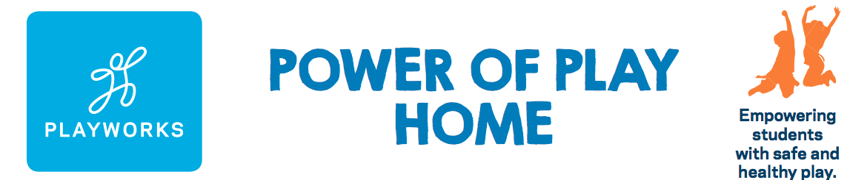

Power of Play Home Pledge Form

Name:
Office Name:
Office Address:
Home Address:
Preferred Email:
Telephone:

New Partner in Play

will commit to an annual Partnership with a financial gift of $ . As a POPH Partner we will also commit to the following:

- Promoting the Power of Play Home Program and Playworks through our marketing channels
- Providing referrals for new POPH Partners
- Visiting a Playworks school to see the transformative power of play.

I will make my gift via:
- Check – please make check out to Playworks Education Energized
- Credit Card – can be made online at playworks.org/arizona

Partner Signature Date

Once you have completed the Power of Play Home Commitment Form, please save and
email a copy to the Playworks team at Suzanne.percy@playworks.org.
Thank you for believing in the Power of Play. Game on!

