Power of Play Home Marketing Tools

Videos:
Bring out the best in every kid - https://youtu.be/Bq-kti6Udzw
Choose Play - https://youtu.be/F5BVhJIK5eA
Playworks for Every Kid - https://youtu.be/knljBK9V3zo
Why we play - https://youtu.be/6Vqu5XRzeSo
Play Works - https://youtu.be/hpwbu_b4dtE

Press Kit & Guidelines:
https://www.playworks.org/about/press-kit/brand-guidelines/
There are quite a lot of details here, including fonts, colors, etc.

Logos:

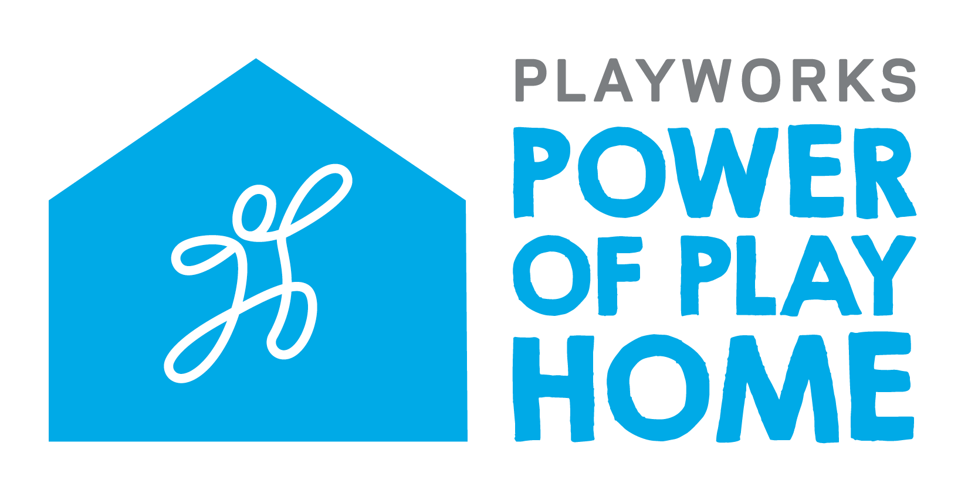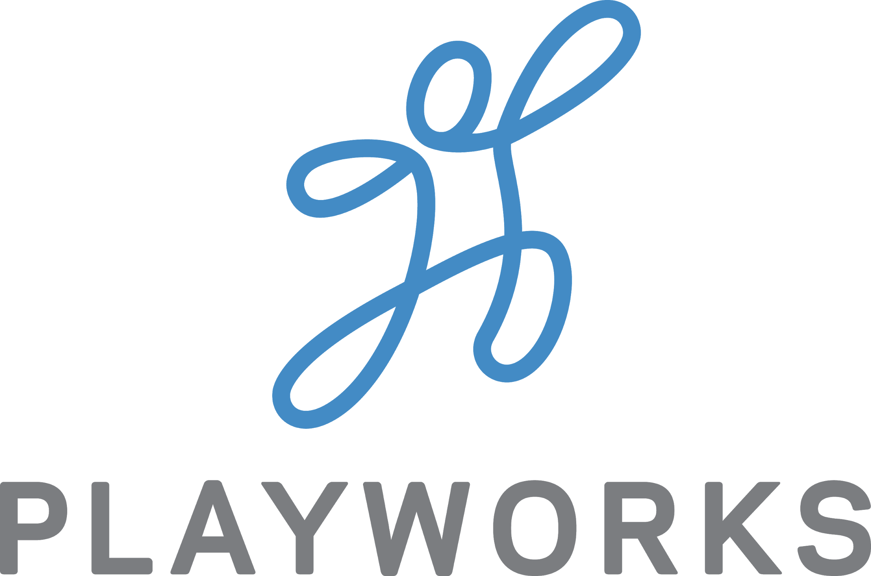

Also, to show your participation in the program, you are welcome to use the logo below in your materials, provided Playworks has received your Commitment Form.
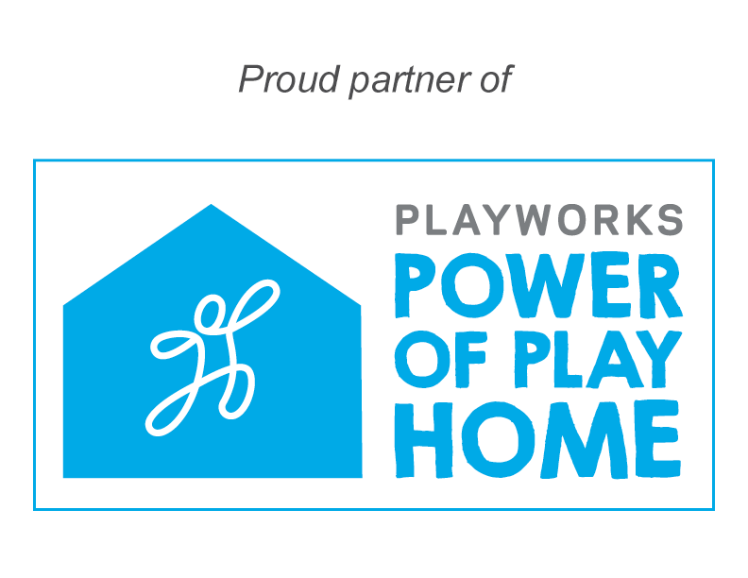

Sign Riders:
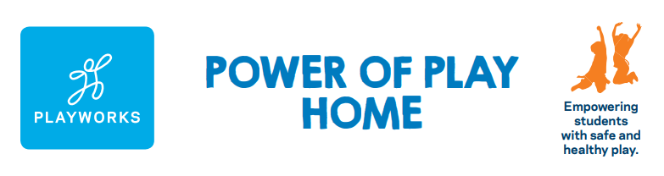
To order sign riders, contact our Thomas Printworks representative, Paul Wilson.

Paul Wilson, Color Sales Manager

paul.wilson@thomasprintworks.com
Office: 602-241-5595
Cell: 602-790-715

Thomas Printworks
817 E. Indian School Rd.
Phoenix, AZ 85014

